Walk 32 Kimbolton, Bache Camp Hillfort and Dovecote
Last walked in April 2018

Description. A 6 km (3¾ mile) walk thru pasture and country lane and passing thru Kimbolton, the Dovecote and Bache Camp Hillfort. Edited walk taken from September 2014 Hereford Times.
Start. Kimbolton St James church. Explorer Map 203 Grid 526616.
Directions from Whitecross Roundabout (Turn milometer to zero. Take the A4110 Canon Pyon (Three Elms road) for 1 mile and TR at the traffic lights onto the A4103 Worcester (Roman road). TL at the first roundabout (2 miles), onto the A49 to Leominster. Go straight across the next two roundabouts (9. 6 miles then 12. 5 miles) and TR at the third roundabout (13. 4 Miles), heading towards Shrewsbury. At 14. 5 miles, when the road bends L, you TR onto A4112 to Kimbolton. At 15. 4 miles, TL up a narrow road, signposted Lower Kimbolton church. Take first L and head to church at 15. 7 miles.

1. Kimbolton. St James Church. With the church spire up to your L, go thru the kissing-gate and down the churchyard path. Exit via a wooden gate and bear L across F1 and towards a lone house. Go thru a kissing gate onto the narrow road/lane and TR. Go down the lane to reach the main road, (a school is on the L). Cross the main road and walk along the No Thru Road, for Minnalls Farm. The narrow road/lane converts into a grassy path as you pass by the farmhouse (R) and go thru a gate. Continue ahead and down, to cross Yolk Brook via a footbridge and metal gate.

2. Yolk Brook Cottage. Go a dozen paces up the path that’s just to the R of the cottage, and then TR and go up the bank and thru a wooden bridle gate into F2. TL, walk up the L edge by the fence, and go thru the next bridle gate into F3 and walk straight on up thru trees to go thru another bridle gate and onto a lane. TL, walk along the lane, and just past the drive to Bachefield Farm (homeward route) you TR up a No Thru Road to Gorsty Hill. Climb up the lane and go past Bache Hill Farm (L), The Field House Farm (L) and Gorsty Hill Farm drive (R). A little further on, near the brow of the hill, you pass a footpath going R and L, you keep ahead, going along the more aggregate permissive path aiming R of three barns. Swing around L past the barns.

3. Upper Bache Dovecote and Farmhouse. Continue on down the aggregated path, winding past brick cottage(s) on your L, and get the first glimpse of an Iron Age camp called Bache Camp ahead at “two o’clock”. Carry on down the wide corridor between fence and hedge, to reach a cropped field. Keep to the hedge on your R, that TR after a short distance, to continue down an enclosed track (wide corridor) to reach the brook. Pass an information board and cross the Whyle Brook via the gated footbridge into F4. Continue straight on up the field that’s to the L of the camp mounds. Pass to the L of a way marked lone tree, and continue on up, to reach a bridle gate in a fence.

4. Bache Camp. Permissive footpath. Go thru the gate into F5 and TL, walk along L tree-lined edge. Go thru the bridal gate ahead and into F6. Bear L and walk down hill,

cutting off the L corner the field, to cross a brook via a gate/a footbridge and gate into F7. Climb very stiffly up next pasture on exactly the same line, keeping near to the L field edge, to go thru gate/stile into F8. Continue straight on up this field to cross a stile into F9. TR, and keep to R field edge to reach the field corner. Ignore the stile in front of you and TR thru a metal gate and along an enclosed grassy track, to go thru another metal gate and onto a narrow road/lane.
1
2
5

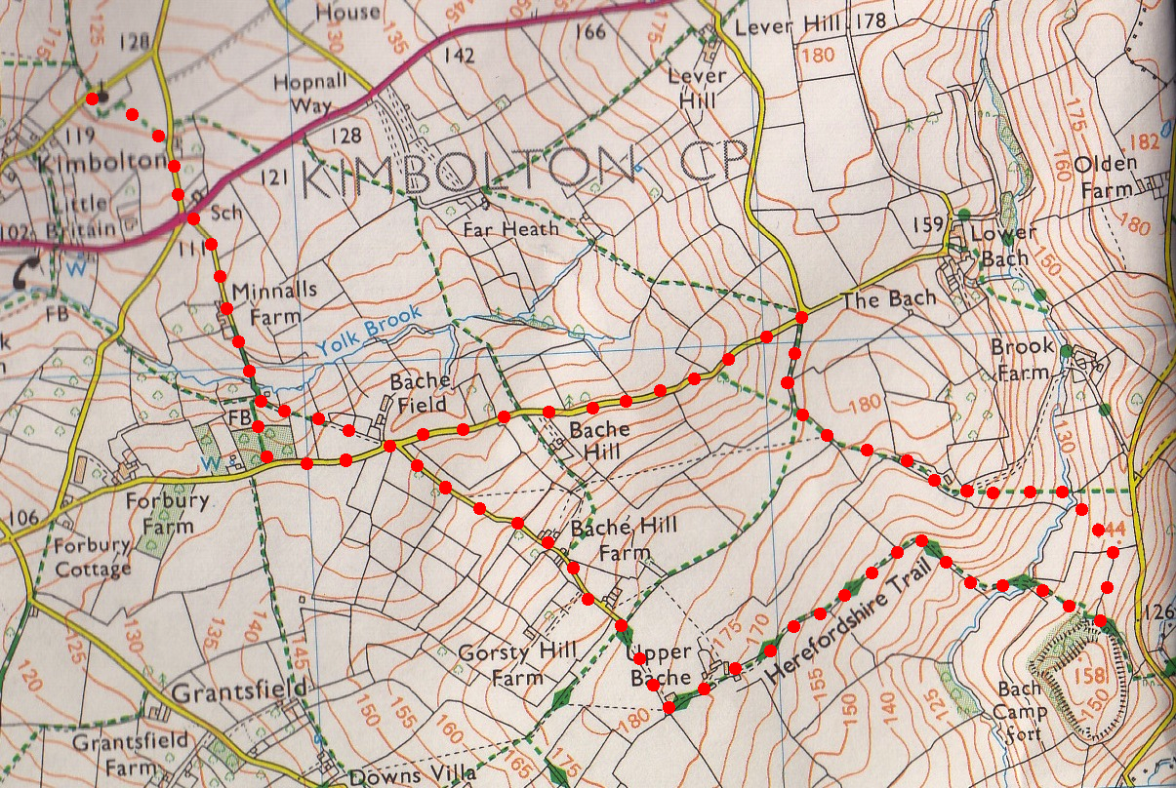
5. Stile on Road. TL and walk down a country lane for about 1km, taking in the countryside views as you travel. When you get to the road junctions at Bachefield Farm, (point 2), go R and walk a couple of yards along the Bachefield Farm drive, to TL thru a metal gate and into F10. Walk up the R field edge/hedge, then down over a stile and into F11. Bear slightly R and go across the field, keeping to the L side of the oak tree, to go thru a metal gate onto a lane/drive. TR to go along the drive to Yolk Brook Cottage (point 2 again). Retrace steps over f/bridge, back up to Kimbolton Church.
3
4

